# EXTENDED ABSTRACT TEMPLATE FOR SUBMISSIONS

Before submitting your proposal, please remember that:

1. The abstract should be sent by e-mail to [imacsss2025@gmail.com](mailto:imacsss2025@gmail.com) from January 15 to March 15, 2025.
2. The abstract must follow this template.
3. The abstracts must be written in English – either the American English or British English.
4. The total length of the extended abstract should be up to 1200 words, considering the sections listed in this template. Authors may modify the titles of the sections to suit their work, but must always respect the style of the template.
5. Abstracts must follow APA 7th edition style for bibliographic references, both in the main text and in the final list. Authors are fully responsible for the style, language, and content of their abstract.
6. Each author may participate in a maximum of three submissions, which must be original and unpublished contributions on any aspect related to martial arts and combat sports under an academic or professional view. The presenting author must be registered and have paid the conference fee (this can be done after the submissions is accepted for presentation at the conference).

***

**Title of your presentation (please follow the style of the example)**

Perceived benefits of martial arts for the elderly: a longitudinal study

**Authors, affiliation and contact e-mail (please follow the style of the example)**

António BLANCO1, Margaret WILSON2, NGUYEN Van Nam3

1 University of Lisbon, Faculty of Sport Sciences. [ablanco@ulisboa.com](mailto:ablanco@ulisboa.com)

2 …

3 …

**Application for IMACSSS Young Researchers Awards**

You can apply for IMACSSS Young Researchers Awards if you are a researcher under 35 years old, Master or PhD student, or awarded with PhD not earlier than 5 years before the conference takes place, not awarded in previous IMACSSS conferences, first author of your proposal and you are going to present it at the conference.

Apply: Yes  No

# [Title]

## 1. Introduction

[Text of the introduction]

## 2. Aims

[Text for the aim(s) of the study]

## 3. Methods

[Text for the description of the methods followed in the study]

## 4. Results and discussion

[Text for presenting and discussing the results of the study. Please follow the example below for tables and figures]

**Table 1.** Mean values for the three groups.

|  |  |  |
| --- | --- | --- |
| **Group** | **Variable 1 (*M* ± *SD*)** | **Variable 2 (*M* ± *SD*)** |
| Group 1 |  |  |
| Group 2 |  |  |
| Group 3 |  |  |
| *Note*: *n* = 40 for each group. | | |

**Figure 1.** Evolution of number of participants in 2023.

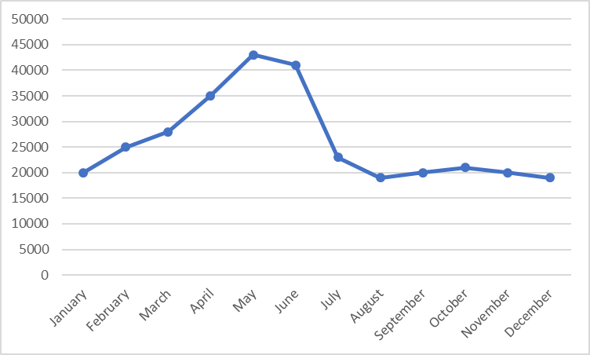

*Note*: Data extracted from Higher Council of Sports (2024).

## 5. Conclusions

[Text for presenting the main conclusions of the study]

## References

[References should be written according to APA 7th edition, include active DOI whenever possible, French indenting and alphabetized. Some examples:

Conte-Helm, M. (1996). *The Japanese and Europe: Economic and Cultural Encounters*. Athlone.

Hoyle, E. (2001). Teaching as a Profession. In N. J. Smelser & P. B. Baltes (Eds.), *International Encyclopedia of the Social & Behavioral Sciences* (pp. 15472-15476). Pergamon. <https://doi.org/https://doi.org/10.1016/B0-08-043076-7/02450-5>

Alcántara-Rubio, L., Valderrama-Hernández, R., Solís-Espallargas, C., & Ruiz-Morales, J. (2022). The implementation of the SDGs in universities: a systematic review. *Environmental Education Research*, *28*(11), 1585-1615. <https://doi.org/10.1080/13504622.2022.2063798>]